* **The detailed data processing and cleaning procedure of labeled peptide database before model fine-tuning**

**(1)** To commence the process, initiate the retrieval of the MaxQuant search output pertaining to HeLa_trypsin by downloading the compressed file from the specified URL: https://ftp.pride.ebi.ac.uk/pride/data/archive/2021/01/PXD019086/Results_HeLa_trypsin.zip. Following successful download and extraction of the contents, systematically extract the RT information and CCS data present in the ‘evidence.txt’ file component of the MaxQuant results. Subsequently, integrate these extracted RT and CCS data points into the corresponding ‘msms.txt’ files. Lastly, carry out a selective pruning operation to eliminate extraneous or irrelevant data entries from the ‘msms.txt’ files to refine the dataset.

**(2)** In the course of data processing, initially limit the data set by preserving the peptide identification with the highest response intensity within each individual sample run. Subsequently, implement a rigorous outlier elimination step where RT for each peptide across distinct sample runs are scrutinized using the 3σ rule. This involves discarding RT values that deviate excessively and retaining just one representative RT per peptide. Following this step, perform a quantitative assessment of the intra-peptide variability by calculating the RSD of the RT for every peptide across all sample runs. Lastly, execute a stringent quality control measure to expunge peptides whose RSD exceeds the threshold of 10%, thus ensuring high consistency and reliability of the retained data.

**(3)** In the course of data refinement, compute the mean RT for each unique peptide across the diverse experimental runs. Subsequently, remove peptides with scores below 40, those having intensities lower than 1e4 counts, and where the RT is less than 10 minutes. This systematic culling process ensures the quality and reliability of the retained data for further analysis.

**(4)** Incorporate the experimentally derived CCS values as computed and presented in the research paper titled ‘*Deep learning the collisional cross sections of the peptide universe from a million experimental values*’. Thereafter, engage in a meticulous matching exercise to substitute the original CCS data points of ‘msms.txt’ file with the article-calibrated and corrected CCS values.

**(5)** Eliminate data within the ‘msms.txt’ file that is not essential for the modeling process. Proceed to analyze and catalog all variable modification categories within the dataset, which reveals that the dataset exclusively includes two types of variable modifications: (ac) and (ox). Following this discovery, undertake the task of reformatting the nomenclature of these modification symbols to adhere to the standardized Unimod format.

**(6)** According to the rules defined by pepMTL, fragmentation descriptors are converted to their respective numerical designations; for instance, replace the term ‘HCD’ with the numeral 2. Following this, implement a filtration step to remove peptide sequences that extend beyond a length of 72 residues from the dataset.

**(7)** Load the prespecified Maxquant ion identifiers into a dictionary named Peaks_dict. Employ a for loop to manipulate the secondary mass spectrum data, formatting it suitably for use in the model. During this iterative process, utilize Peaks_dict to map the intensity values of the corresponding ion fragments found in Ioni to their fixed positions within the array PI_intensityi. Conclude by assigning a value of zero to any positions where there is no recorded ion fragment intensity.

**(8)** During the phase of data cleaning, initially establish a rough predictive regression model for RT. Assess the prevalence of aberrant observations within the dataset. Should there be a considerable proportion of outliers that substantially compromise the fitting process when constructing the definitive model, move forward to the next tier of data cleaning measures. On the other hand, should the count of anomalous samples be minimal and not materially impair model fitting, opt not to proceed with additional data cleaning procedures.

**(9)** We implement a streamlined workflow for building and training an ordinal classification model leveraging the transformers library. It starts by initializing an ‘AutoModelForSequenceClassification’ from transformers, which forms the core of the classification model. To enhance the training process, this model is integrated into a custom AcceleratedNet class that extends AccelerateMixin and NeuralNetClassifier classes, enabling automatic mixed precision (AMP) training with half-precision floating-point format (mixed_precision=’fp16’) to optimize GPU resource usage and speed up computation. Subsequently, the code utilizes sklearn's ‘Pipeline’ to create an end-to-end machine learning workflow. This pipeline begins with a preprocessing step employing the ‘HuggingfacePretrainedTokenizer’ to tokenize input text based on the selected pre-trained model. The tokenized inputs are then fed into the accelerated AcceleratedNet classifier, which has been configured with appropriate hyperparameters like the optimizer, learning rate, maximum epochs, and batch size. By integrating the ‘AcceleratedNet’ within the sklearn pipeline, the entire process from tokenization to model training becomes seamless and optimized for performance, while maintaining the capability to detect and handle potential label noise using cleanlab.

**(10)** Utilizing the cleanlab software, the process for removing anomalous RT samples involves several steps. Initially, the RT are evenly distributed into 21 bins. Subsequently, the labels are subjected to label encoding using the ‘LabelEncoder’ function from the sklearn.preprocessing module. Next, the developed pipeline is integrated with the ‘CleanLearning’ method from the cleanlab library. This integration allows for a 10-fold cross-validation procedure to be performed on the training data. In the process, out-of-sample predicted probabilities are computed for each example, which are then utilized to identify potential label issues, essentially pinpointing likely mislabeled data points. Finally, the result obtained from ‘cl.find_label_issues’ is analyzed, and data points are flagged as anomalous if the absolute difference between the given label and the predicted label surpasses a threshold of 1. This serves as a criterion for detecting and excluding those RT samples that might negatively influence the model’s training and overall performance.

**See the following jupyter file for detailed operation code and running records:**

* "./pepMTL/fine_tune_data/**1_PXD019086_data_processing.ipynb**"
* "./pepMTL/fine_tune_data/**2_Data processing before model training.ipynb**"
* "./pepMTL/fine_tune_data/**3_pretraining for RT.ipynb**"
* "./pepMTL/fine_tune_data/**4_False RT data filtering by cleanLab.ipynb**"
* **The detailed code execution tutorial for pepMTL model training**

This tutorial will guide you through the process of training the pepMTL model, a multi-task learning model for the prediction of RT, CCS, and MS/MS of peptides. The model is built using the pre-trained ESM-2 language model as the backbone and is trained on a dataset of peptide sequences and their corresponding RT, CCS, and MS/MS data.

* **Prerequisites**

Before running the code, make sure you have the following prerequisites installed:

1. Python (version 3.11.0)
2. NVIDIA GPU (the code is designed to run on a system with an NVIDIA GPU)
3. Miniconda (or Anaconda)
4. Required Python packages: PyTorch, Transformers, Datasets, NumPy, Pandas, SciPy, Scikit-learn, Tqdm, and ms_entropy

* **Setup**

Specific version of the python environment and toolbox listed in requirements.txt has been verified to be available.

1. Install Miniconda: If you haven’t already, install Miniconda on your system.
2. Create a Python environment: Open the Anaconda Prompt and create a new Python environment named "pepMTL" with Python version 3.11.0 using the following command:



1. Activate the environment: Activate the "pepMTL" environment using the following command:



1. Download the pepMTL package: Download the pepMTL package from GitHub and extract it to your desktop. Navigate to the extracted folder using the following command:



1. Install PyTorch: Install the required version of PyTorch with CUDA support using the following command:



1. Install dependencies: Install the remaining dependencies using the provided requirements.txt file:



1. Open Spyder: Open the Spyder IDE by running the following command:



* **Data Preparation**

The code assumes that you have already prepared your training and test datasets in the form of pickle files (Train_data.pkl and Test_data.pkl) located in the ./fine_tune_data/ directory. These pickle files should contain pandas DataFrames with the necessary columns for peptide sequences, RT, CCS, MS/MS intensities, and other relevant features.

1. Open the training script: In the Spyder IDE, open the pepMTL_train_FAMO.py file.



1. Load the data: Follow the instructions in the script to load the training and test datasets.

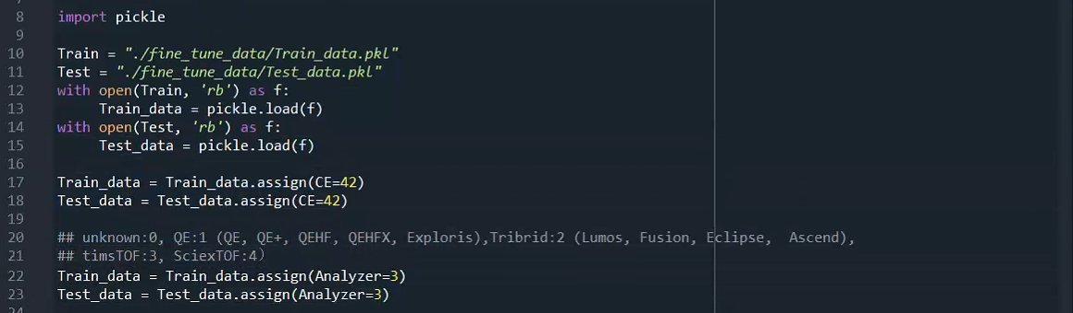

1. Preprocess the data: Follow the instructions in the script to preprocess the training and test datasets.

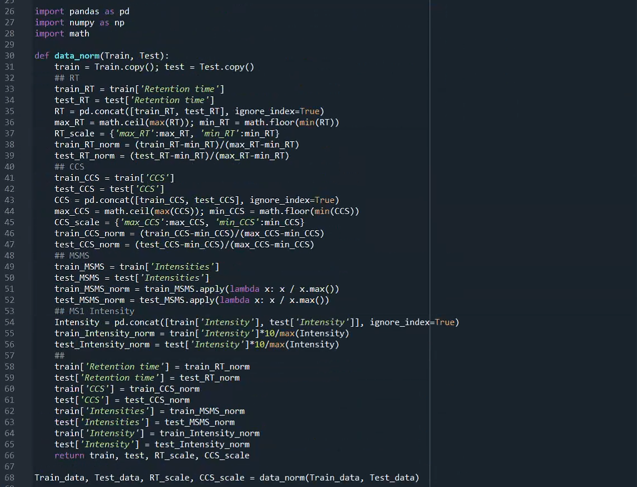



1. Convert the Dataframe to a Hugging Face dataset: Hugging Face Dataset objects are memory-mapped on the drive, so they are not limited by RAM memory, which is very helpful for working with large datasets.



* **Model training and testing**

The pepMTL framework employs a multi-task learning approach to simultaneously predict three critical properties of peptides: RT, CCS, and MS/MS. The model leverages the power of the pre-trained ESM-2 language model, a state-of-the-art protein language model, as its backbone. The training process is designed to fine-tune the pre-trained model on a dataset containing peptide sequences and their corresponding RT, CCS, and MS/MS data. Once the training is complete, the model_test function is used to evaluate the trained model on the test dataset. This function calculates performance metrics such as *R*2, RMSE, and UES for RT, CCS, and MS/MS predictions. These metrics provide a comprehensive assessment of the model performance on unseen data.

1. Tokenize the data: The script uses the pre-trained ESM-2 tokenizer to tokenize the peptide sequences.

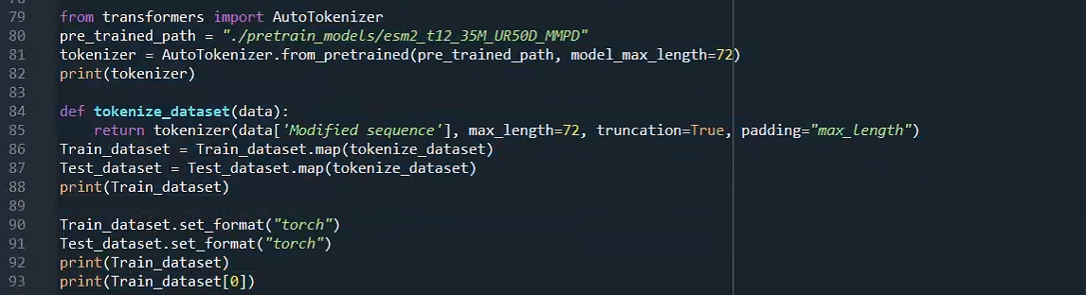

1. Build the pepMTL model: The script defines the pepMTL model architecture, which is a multi-task learning model with separate prediction headers for RT, CCS, and MS/MS.

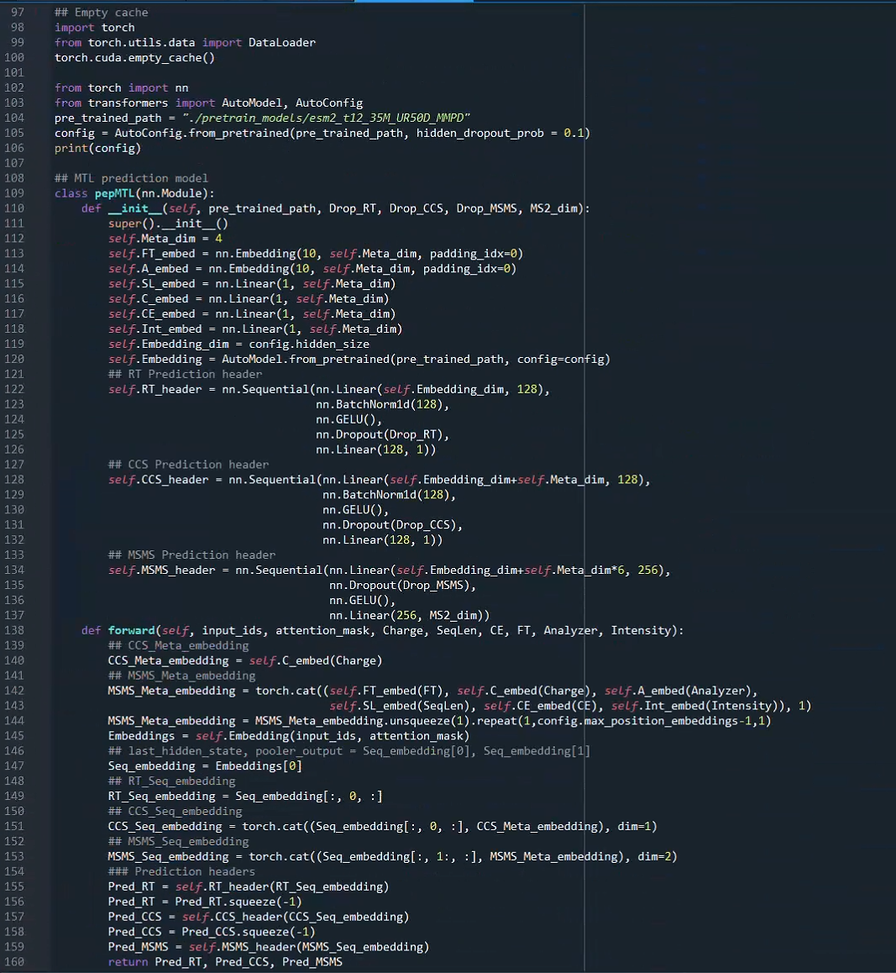

1. Define five similarity calculation function: for MS/MS similarity calculation

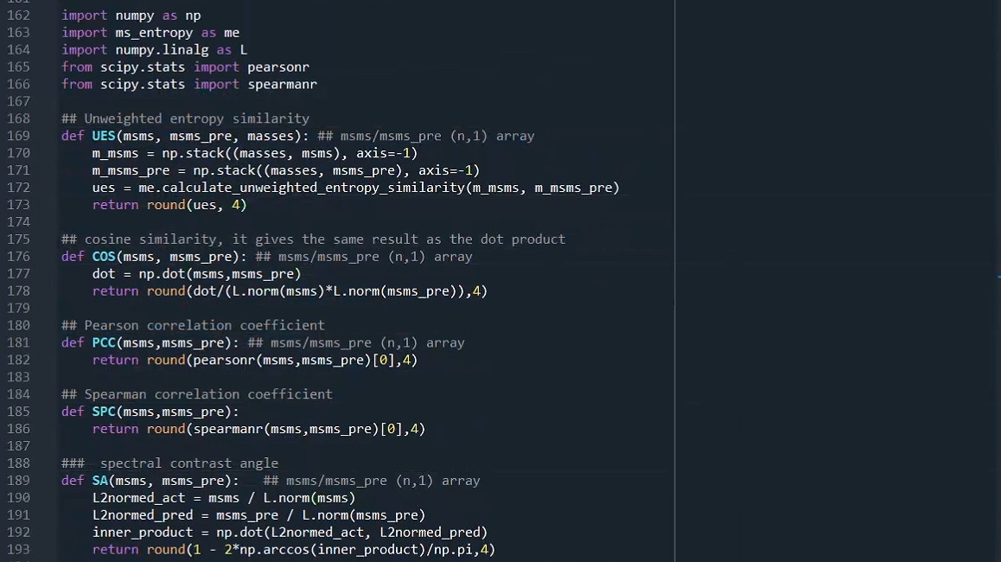



1. Define the training function: The script provides a model_train function that handles the training loop for the pepMTL model. It uses the FAMO (Fast Adaptive Multitask Optimization) algorithm to automatically adjust the loss function weights for the multi-task learning problem.

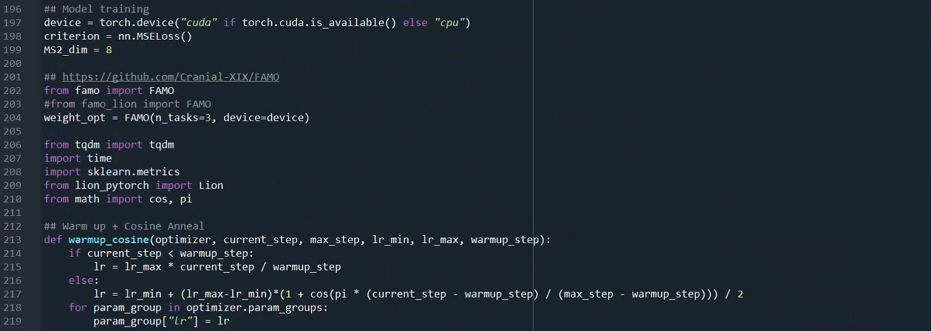

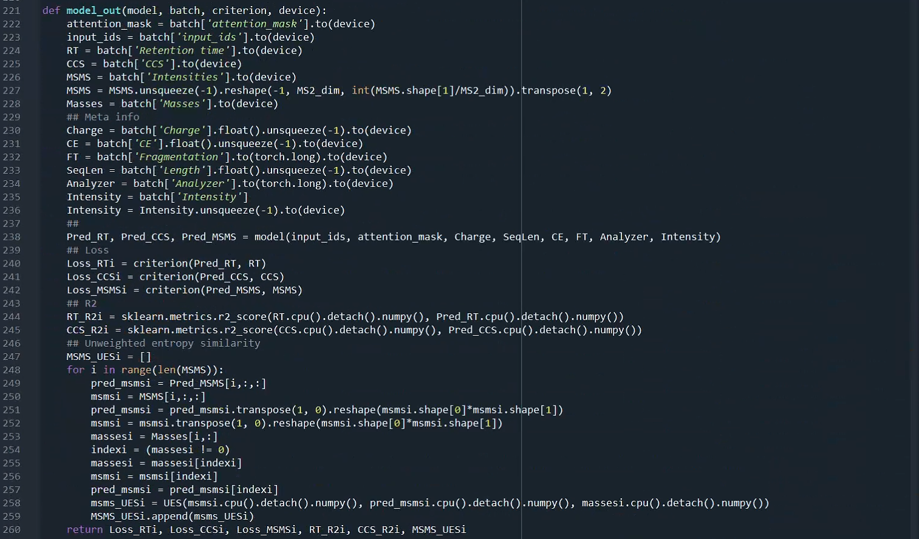

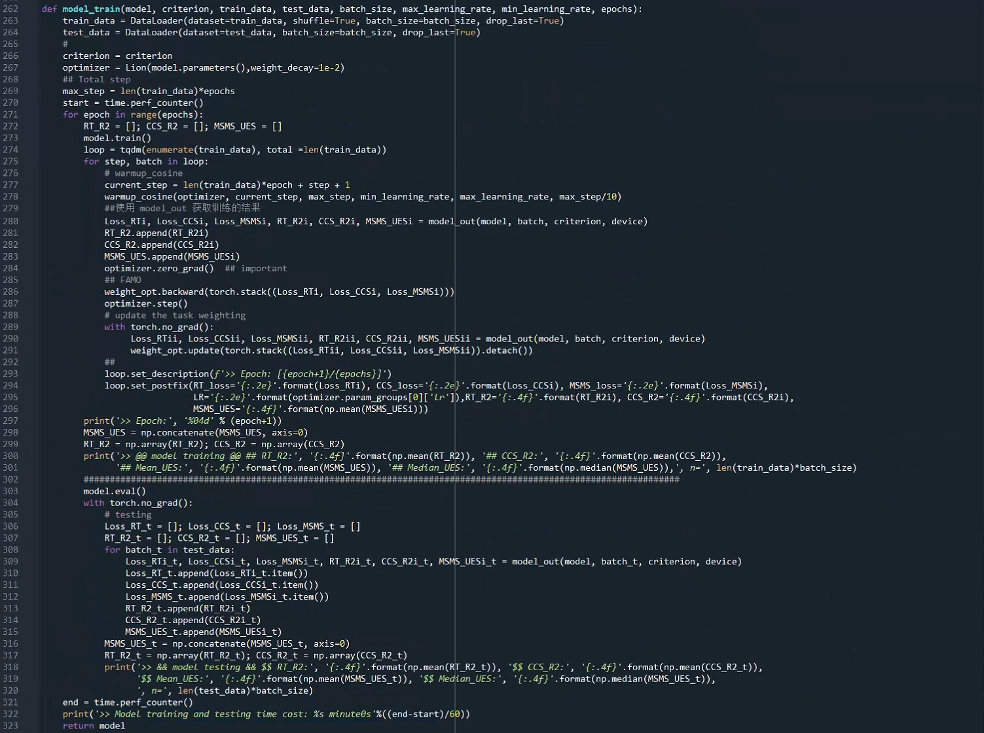

1. Train the model: Follow the instructions in the script to instantiate the pepMTL model and call the model_train function with the appropriate hyperparameters (e.g., batch size, learning rates, and number of epochs). During training, the script will display the current epoch, losses, *R*2 of RT and CCS, and UES of MS/MS for the training and validation sets.

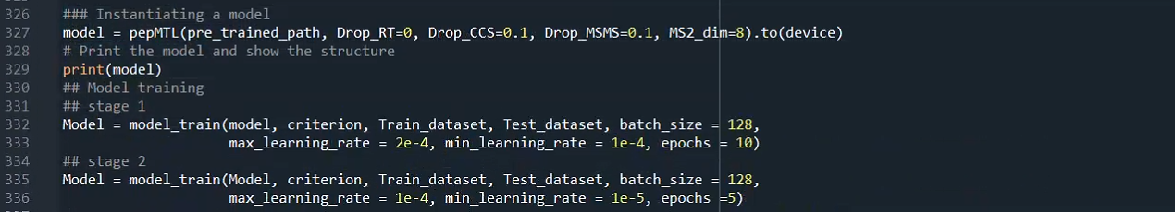

1. Test the model: After training, the script provides a model_test function to evaluate the trained model on the test dataset and calculate performance metrics such as *R*2, RMSE, and UES.

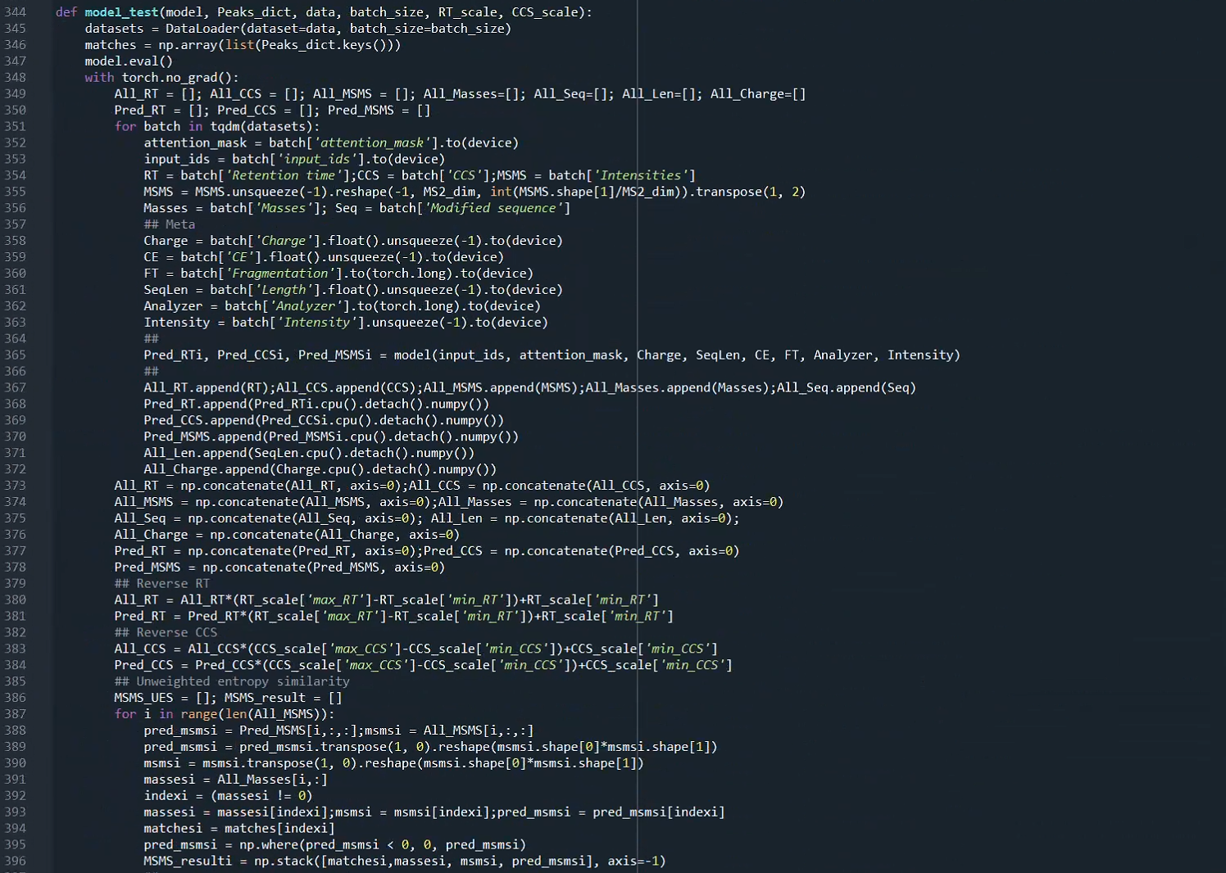



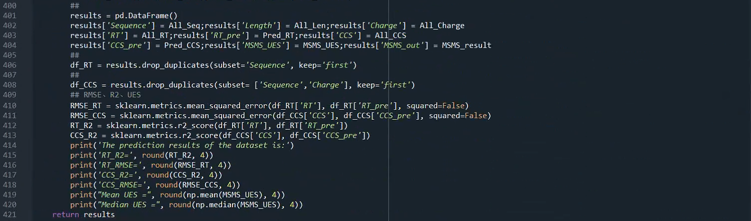

1. Save the model and results: Finally, the script allows you to save the trained model and the training/test results using torch.save function and the pickle module.

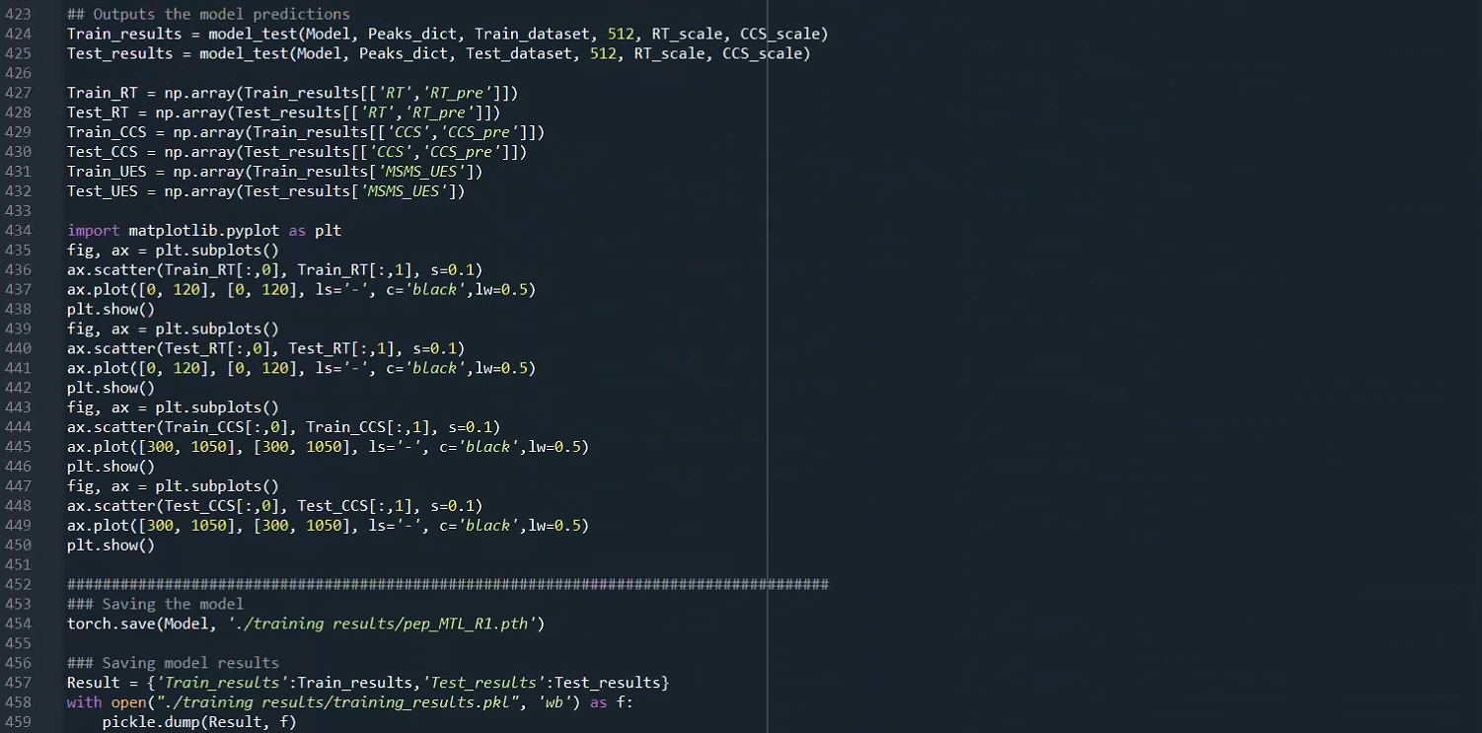

* **Note**

This script is specifically designed for training the pepMTL model on peptide data. Modifications may be required to adapt it for other types of data or models.